**Write a program in C++: which will first store table into a file and then display on screen form the file.**

**• Program will take 3 input:**

**▪ TableValue: 10**

**▪ Final value: 8**

**▪ File Name:Table of 10**

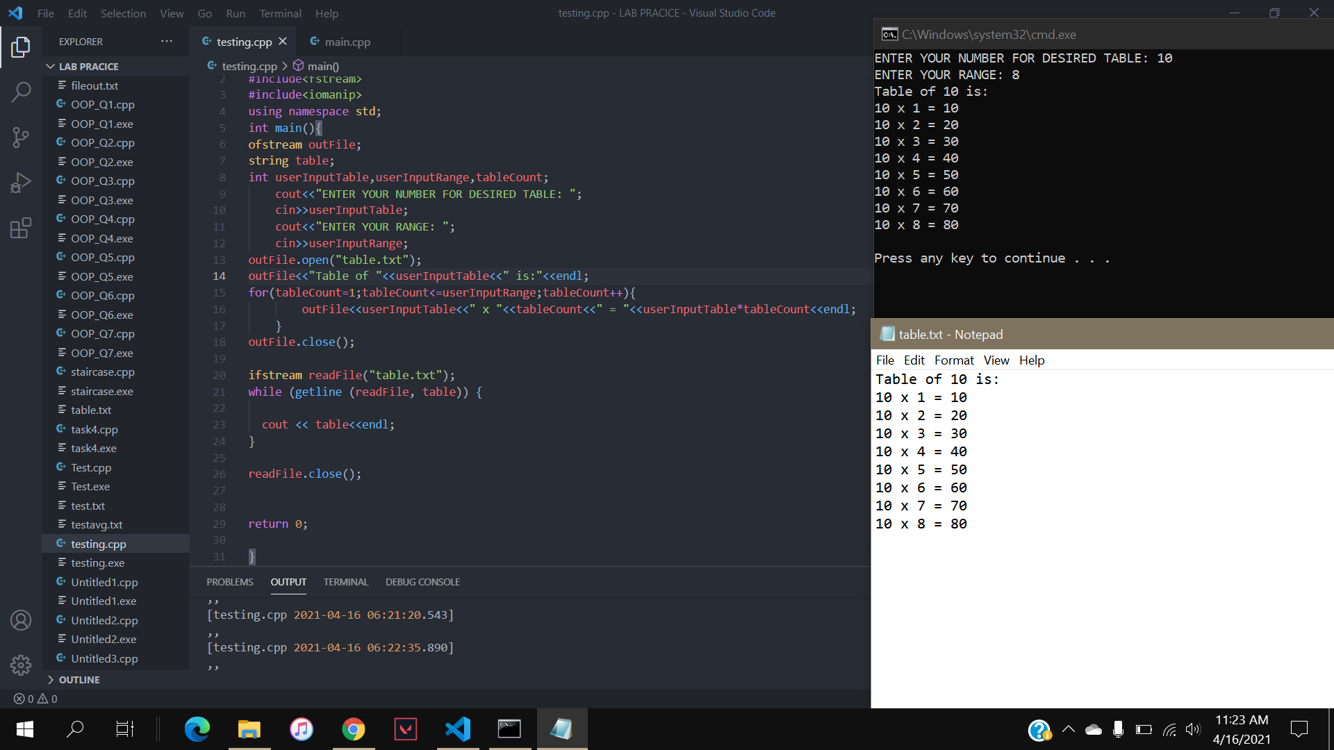

**Write a program in C++ to Find the Number of Lines in a Text File.**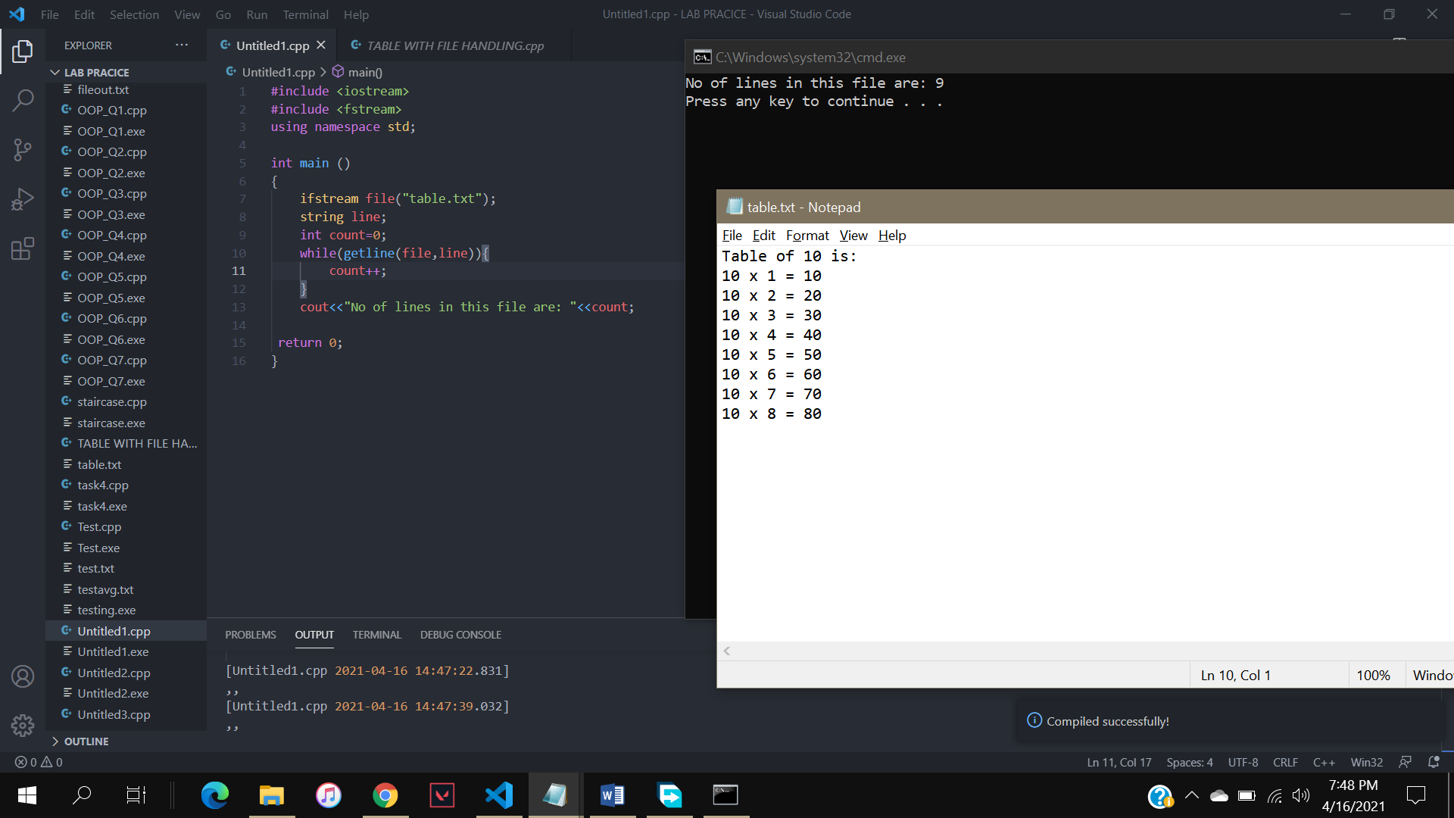

**Write C++ program determines the money to be donated to a charity.**

**• It prompts the user to input**

**• The movie name,**

**• Adult ticket price,**

**• Child ticket price,**

**• Number of adult tickets sold,**

**• Number of child tickets sold, and**

**• Percentage of the gross amount to be donated to the charity.**

**• Store output in a file (Use manipulator like setw, setfill, right, left, etc. )**

CODE(a)

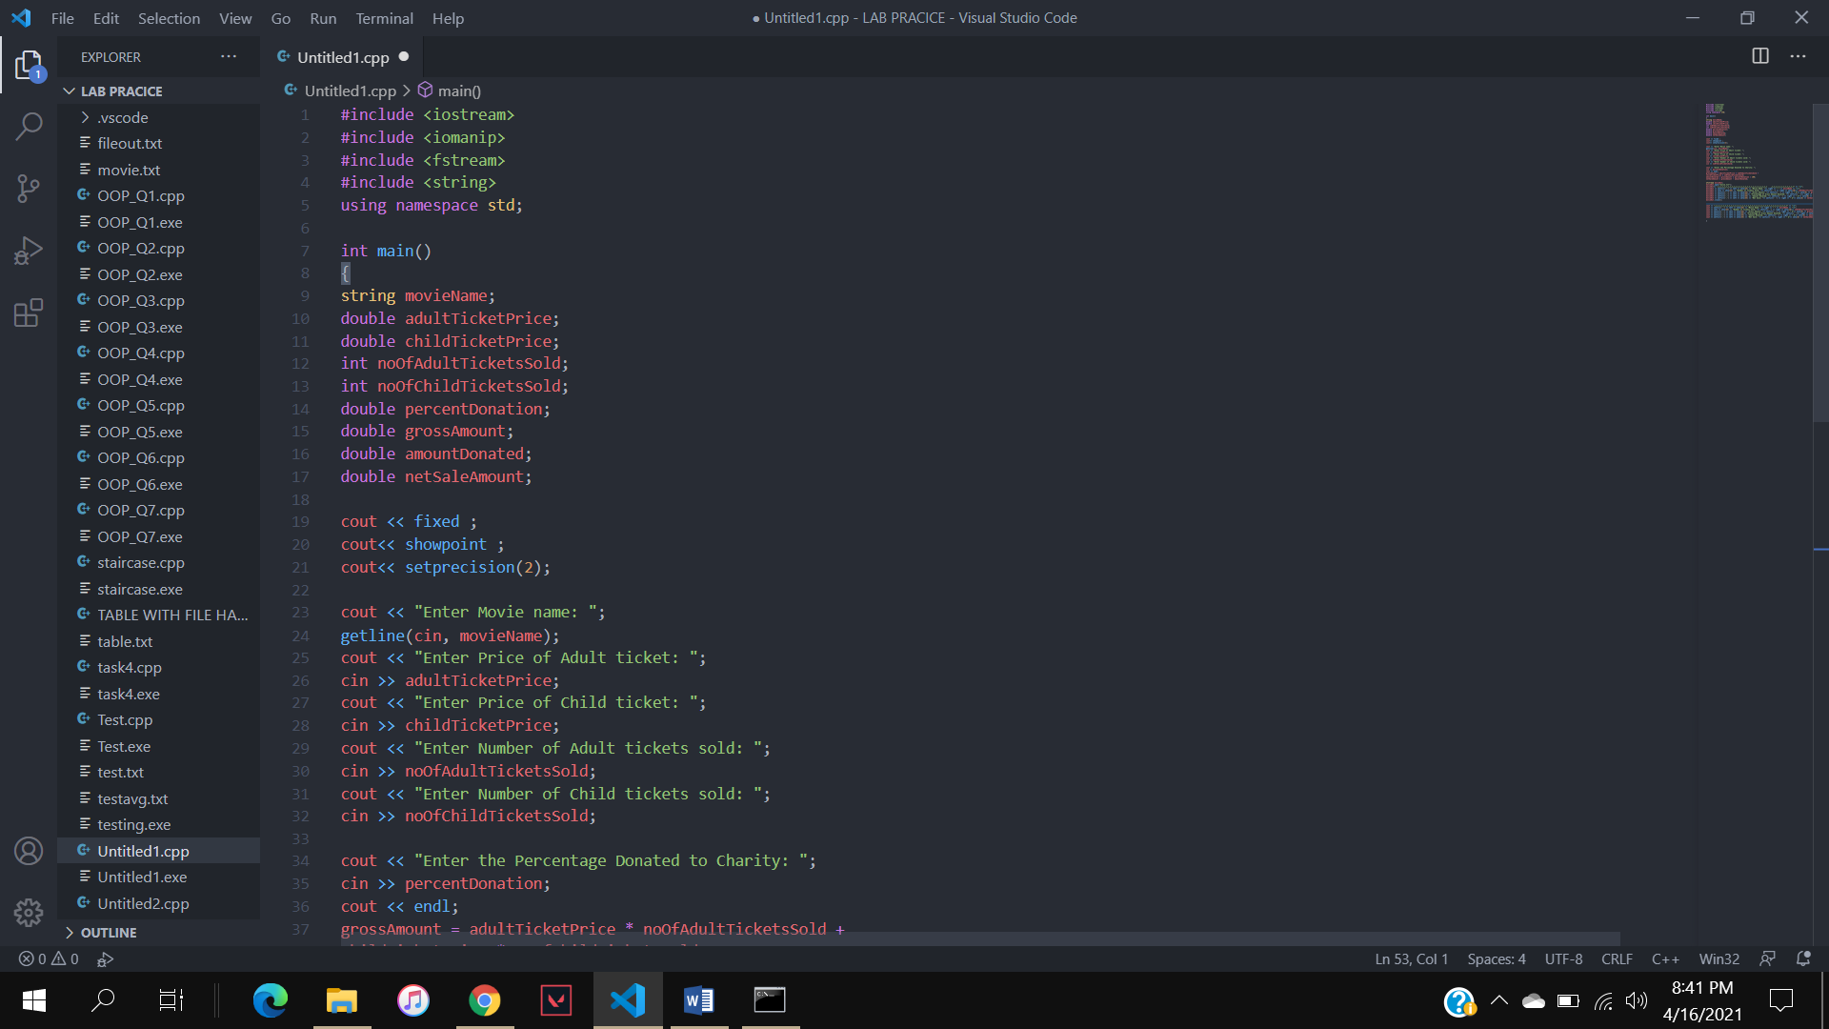

CODE(b)

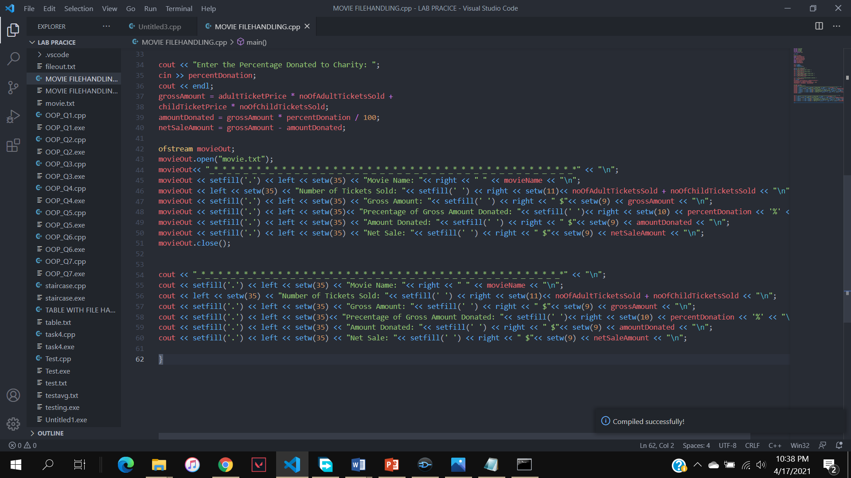

CONSOLE OUTPUT

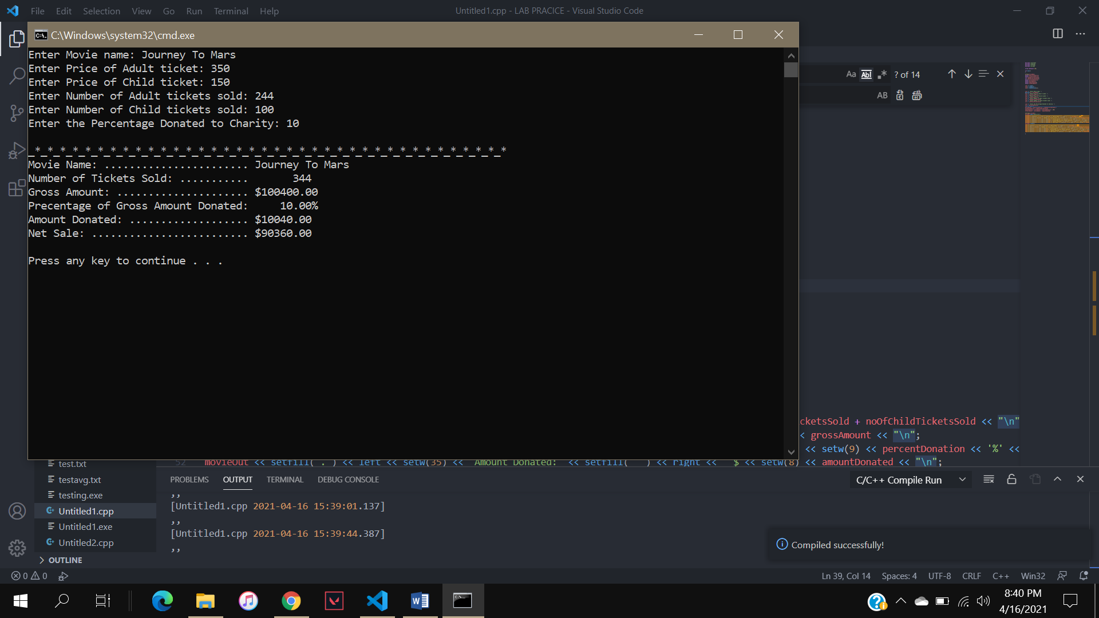

NOTEPAD OUTPUT

